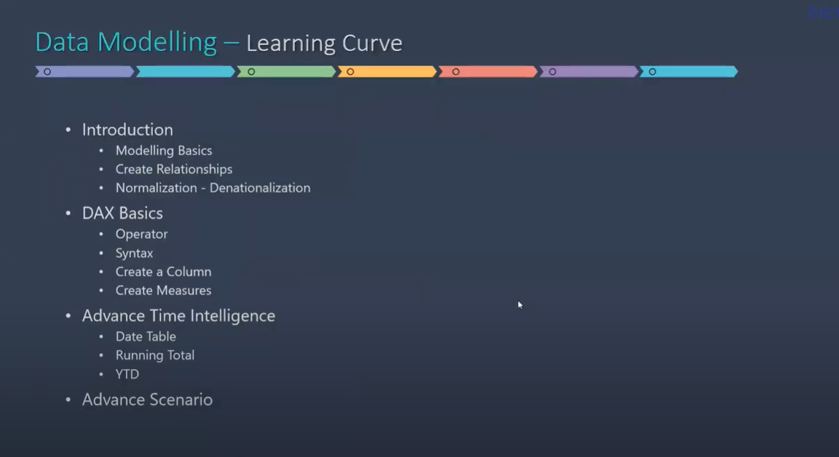

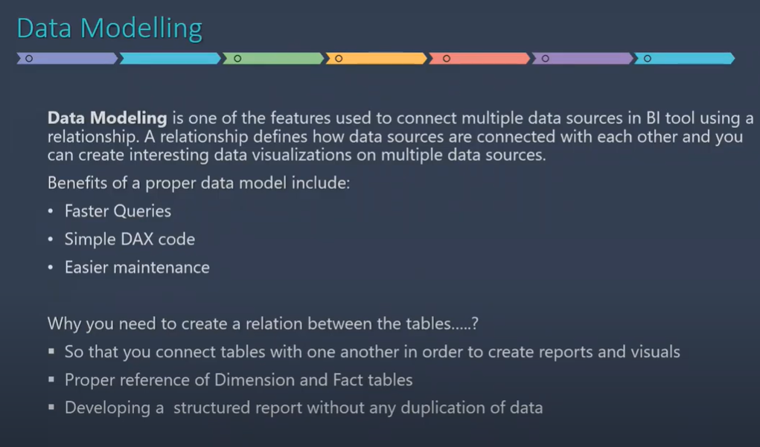

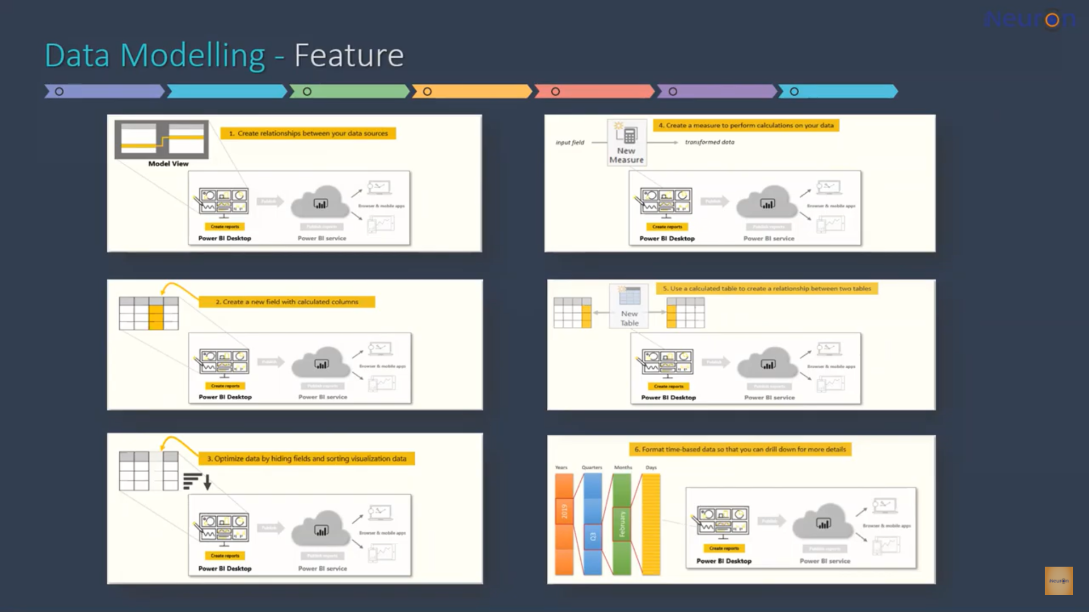

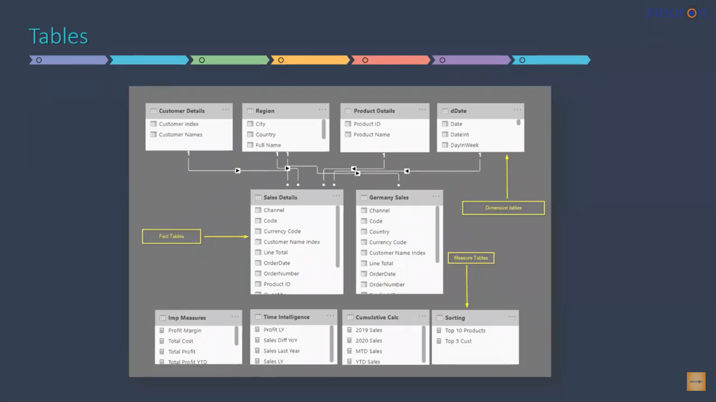

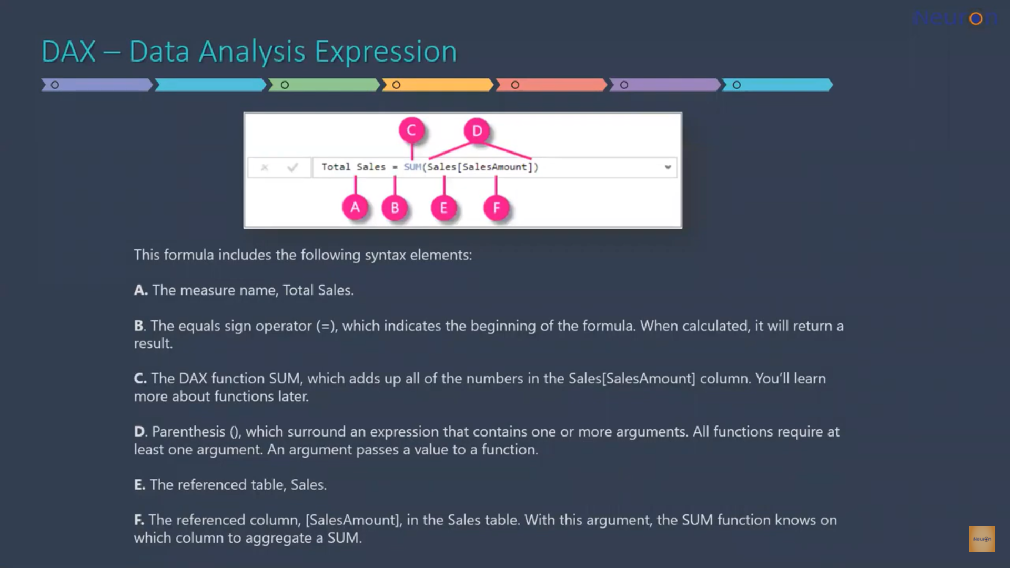

Data Set: Lupin Meds

Select all the tables and load them into power query editor.

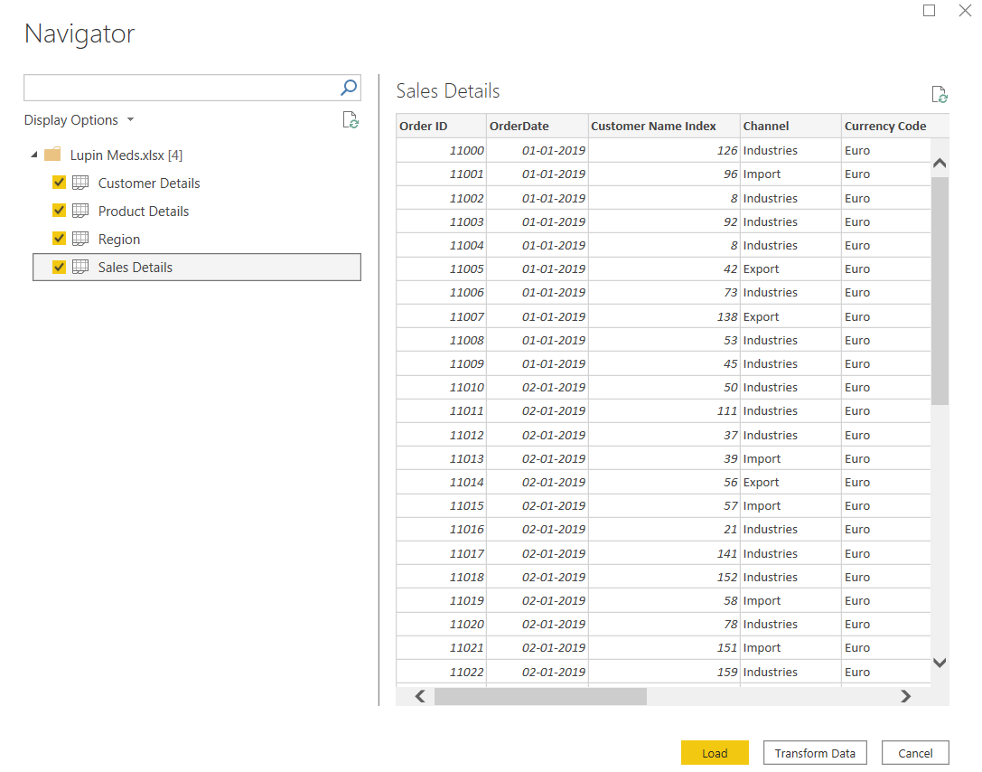

Take a glance at the tables, all the data should be properly loaded. Close and apply.

We will focus on data view and the model view for data modelling purpose.

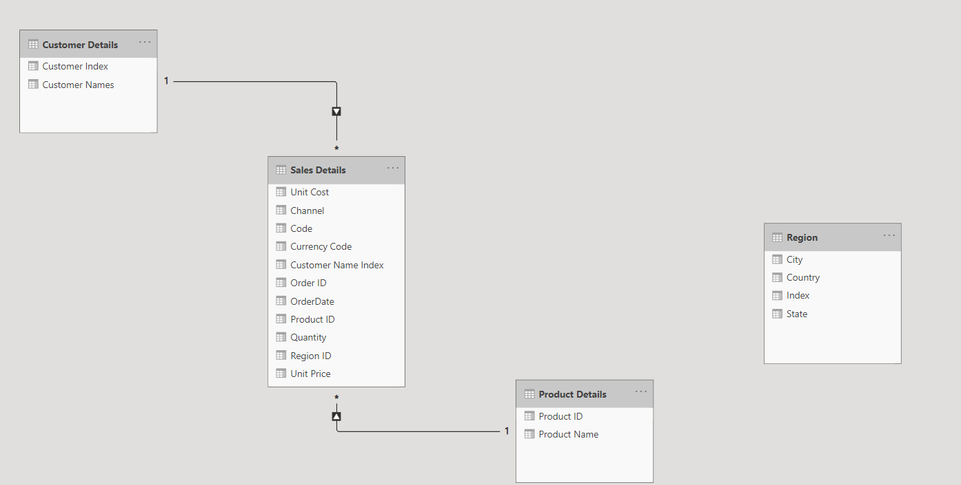

Remove the default connections.

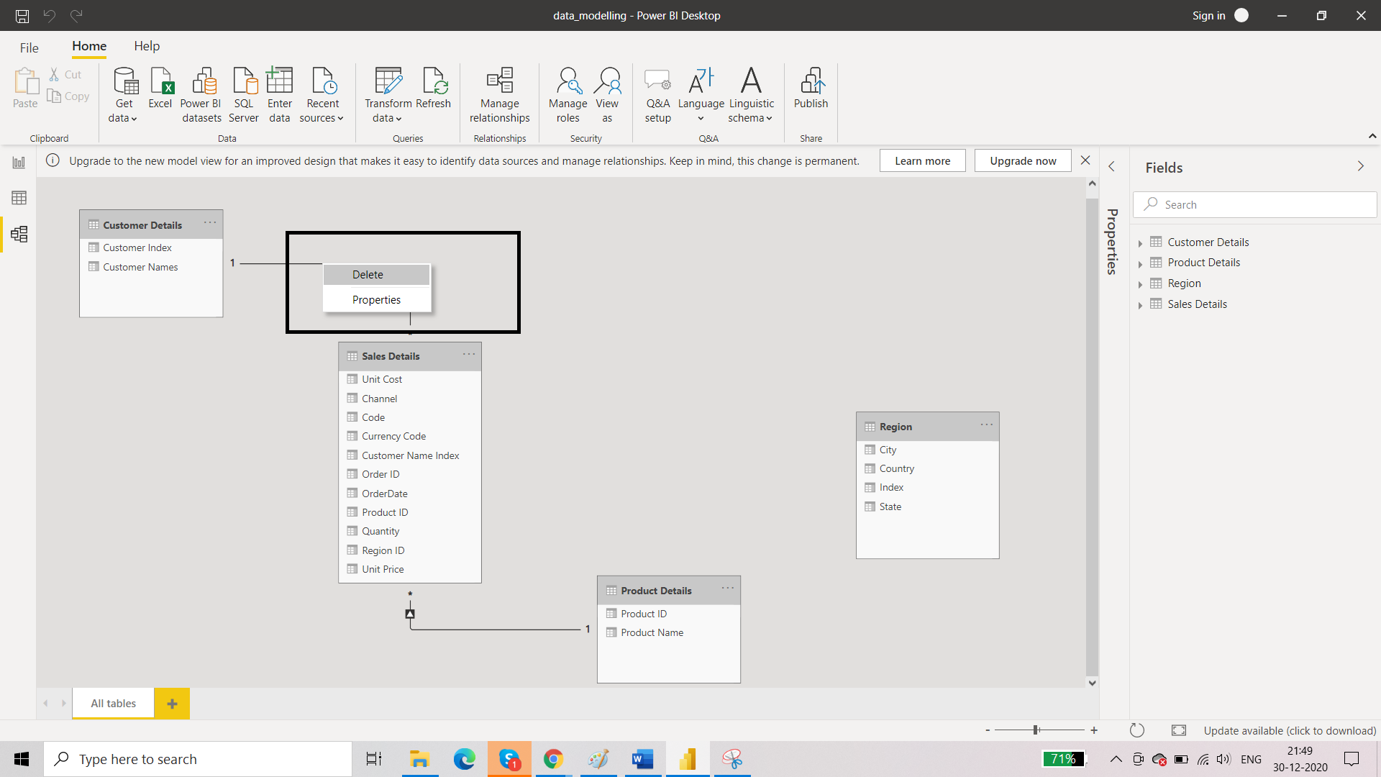

Result:

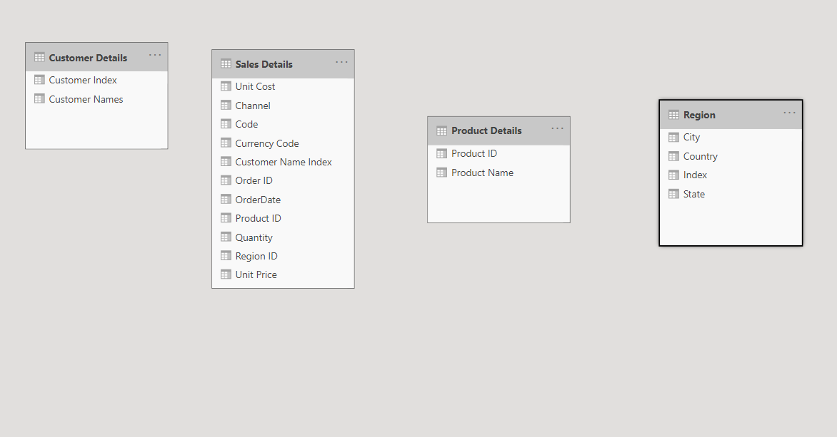

Keep fact tables and dimension table at different levels.

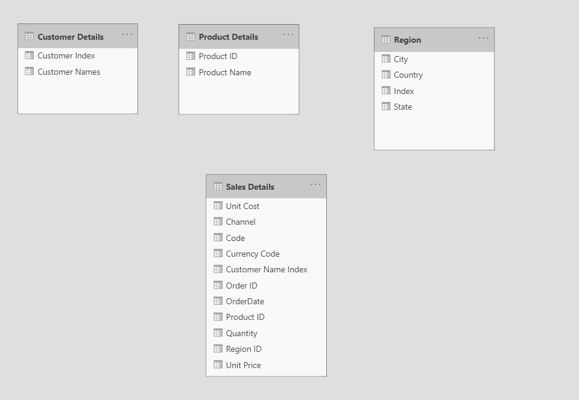

Check if there is a requirement of any table. If yes then what kind of table? Is it fact table? or dimension table?

Date table is missing from the model view. It can be a part of data modelling operations later and is present in sales details table too.

This Date table is going to be a dimension table. And there is going to be unique data here. Unique date values are going to be there in this table. In sales details table which is a fact table, there are duplicate values of date which means that multiple transactions took place on a particular date. We want a data table in which date values are unique.

REUIREMENT 1: The data model is incomplete. There is a need to add Date Table which is going to be a dimension table.

Go to Data View. Home 🡪 Calculations 🡪 New Table

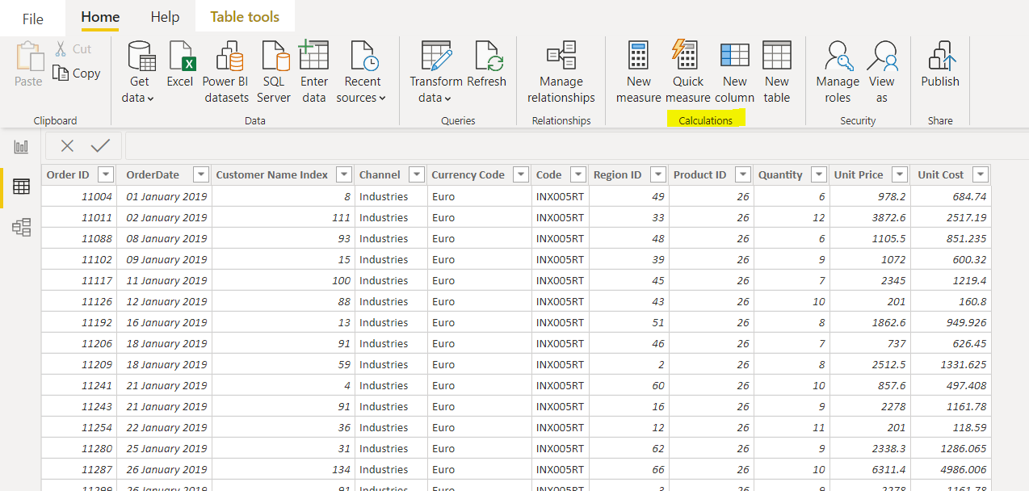

Alternatively, we can use Report View. We have same options here except New Table.

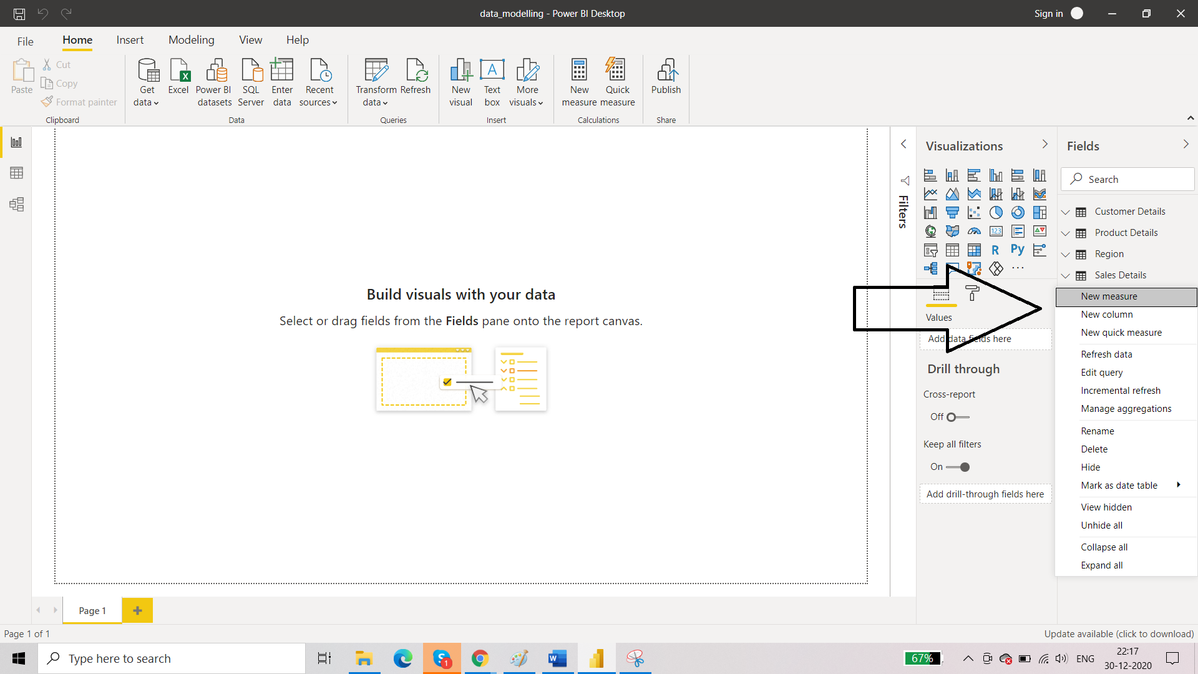

By going as per option 1:

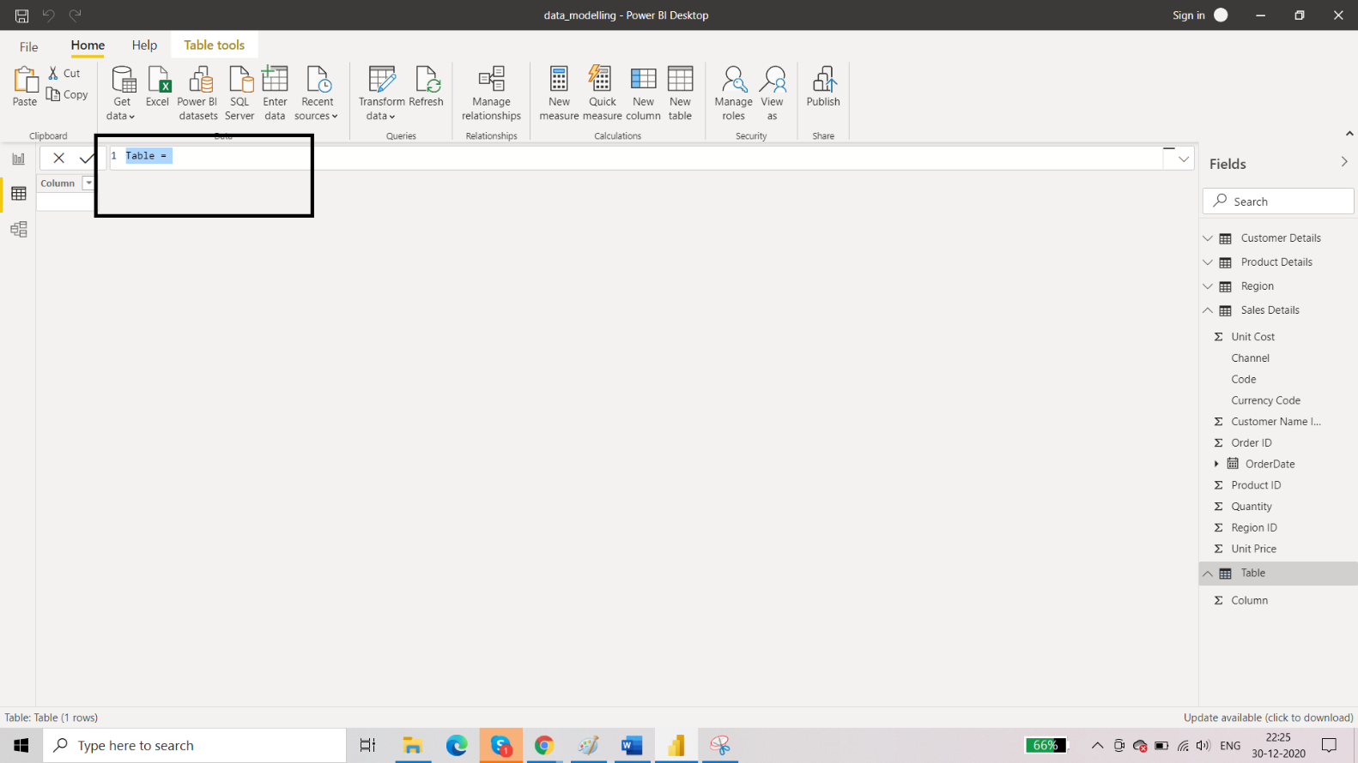

Rename the table as Date Table. To create dimension table we have two options. First is to use DAX formula in data model view and second is to use M Function Codes in power query editor.

**USING DAX TO CREATE DIMENSION TABLE**

We are going to name the table as “Date”

We have several functions here just as excel and we are going to sue Calendar function. It accepts two arguments: start date and end date and returns a table with all the dates in between them. This data set is expanded from 2019 to 2020. So, we will enter 1/1/2019 and 31/12/2020 as the start date and end date respectively.

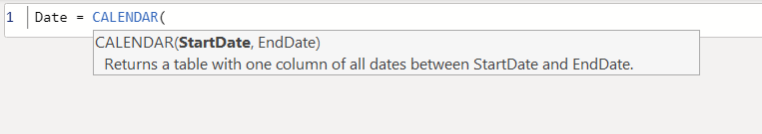

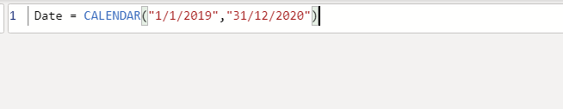

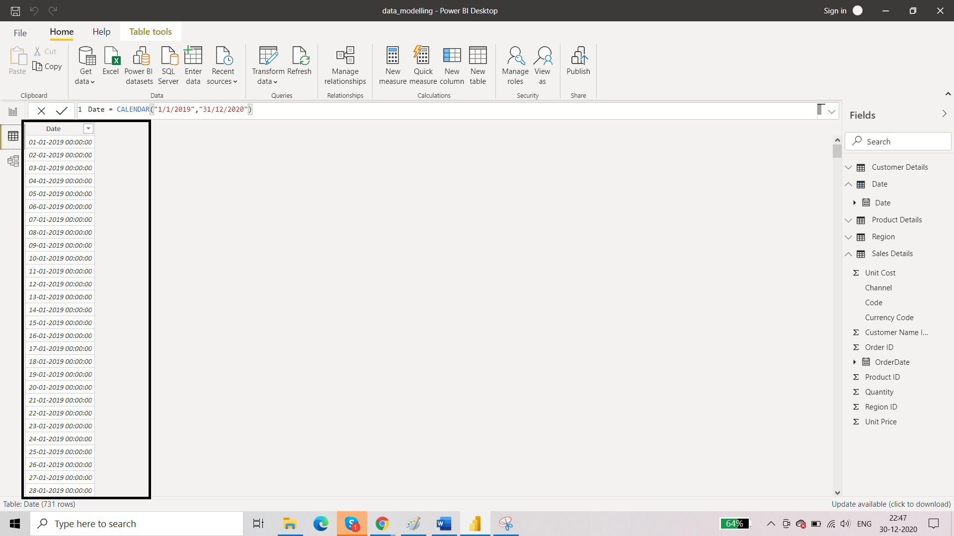

In PowerBI whenever we are creating a date table using DAX, we need to mark that table as ‘date’ table. This is not necessary for other tables. But we need to tell power Bi that we are going to include a date table in our data model. Power BI will verify on its own whether that table can be considered as a date table or not:

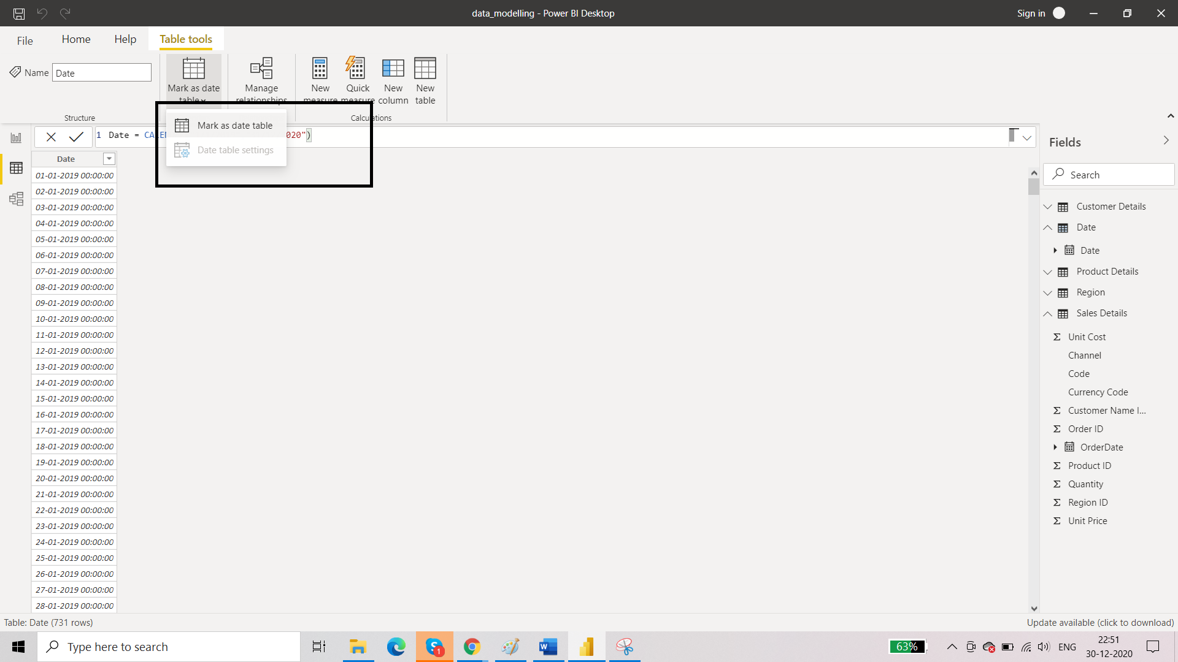

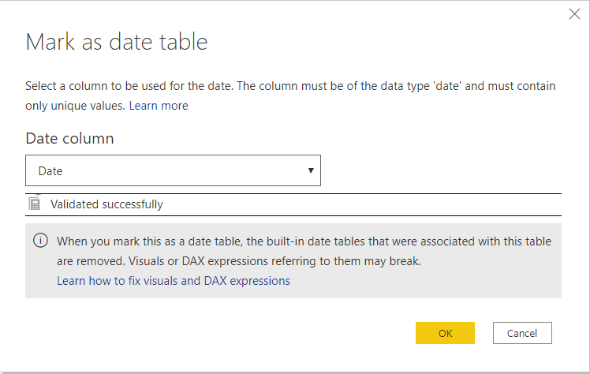

Validation is successful. This table is marked as a date table.

Now we need to format this column. This has time component too which is not needed and we need the dates in proper format of date, month, year. Change the format:

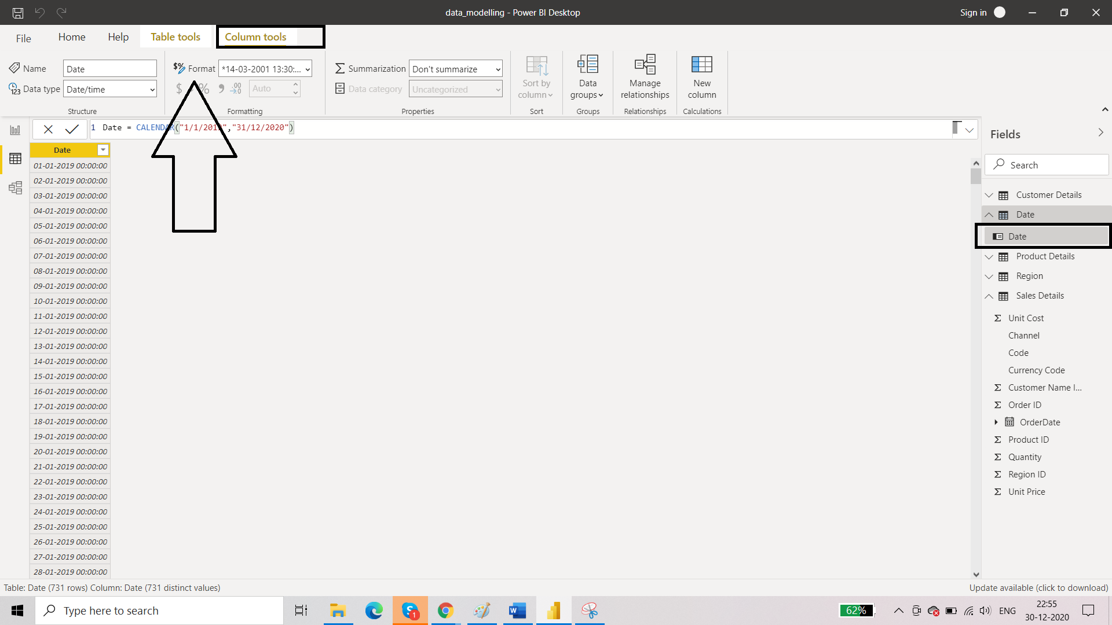

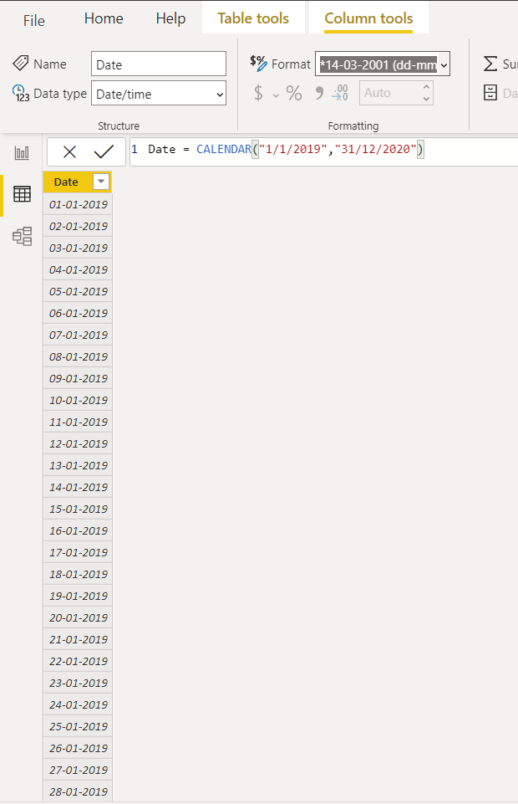

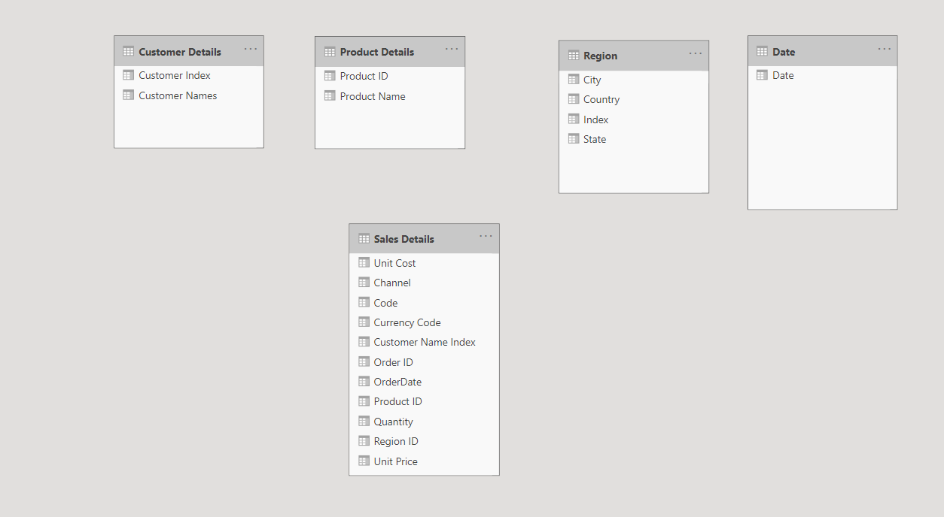

REUIREMENT 2: Extracting month from the date table (with the help of DAX formula)

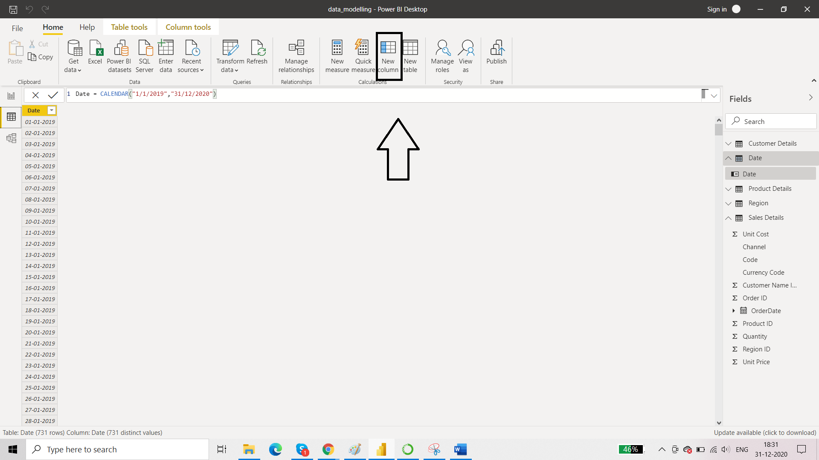

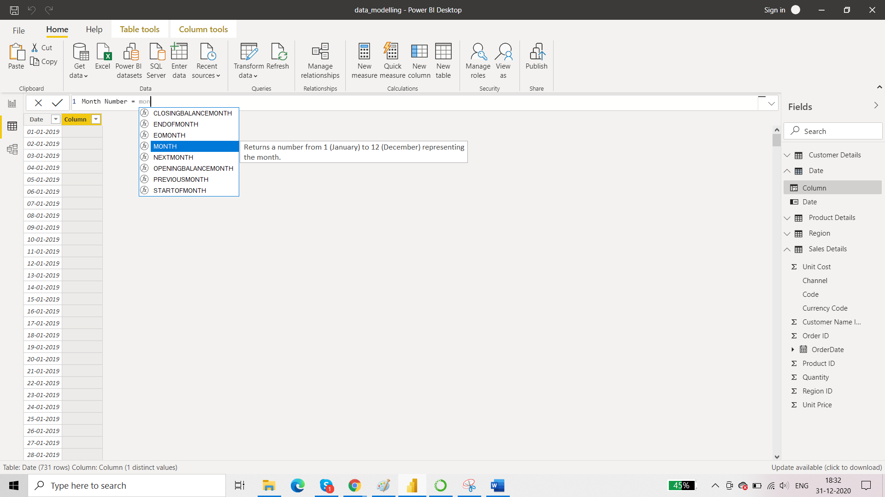

This month function takes only one argument that is date. You can see in the suggestions and add Date column as the argument here.

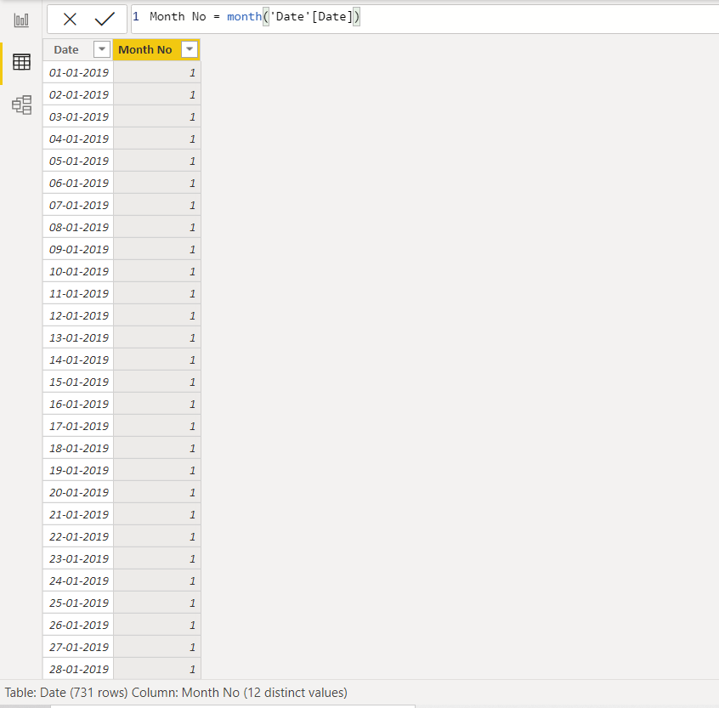

REUIREMENT 3: Extracting month name the date table (with the help of DAX formula)

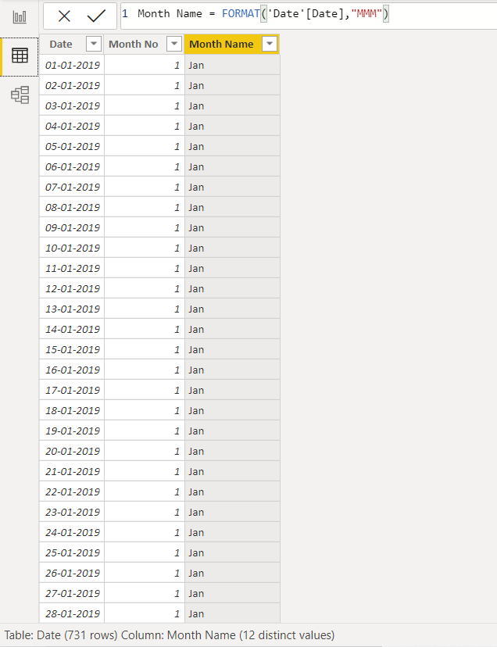

REUIREMENT 4: Extracting week number the date table (with the help of DAX formula)

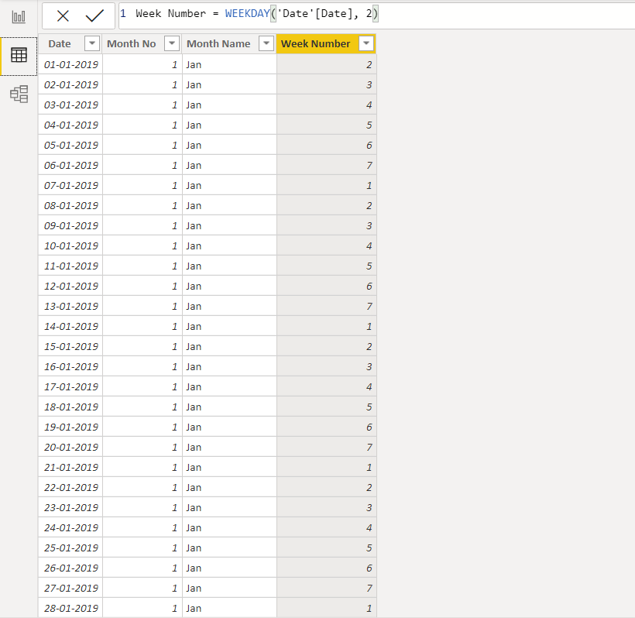

REUIREMENT 5: Extracting week day the date table (with the help of DAX formula)

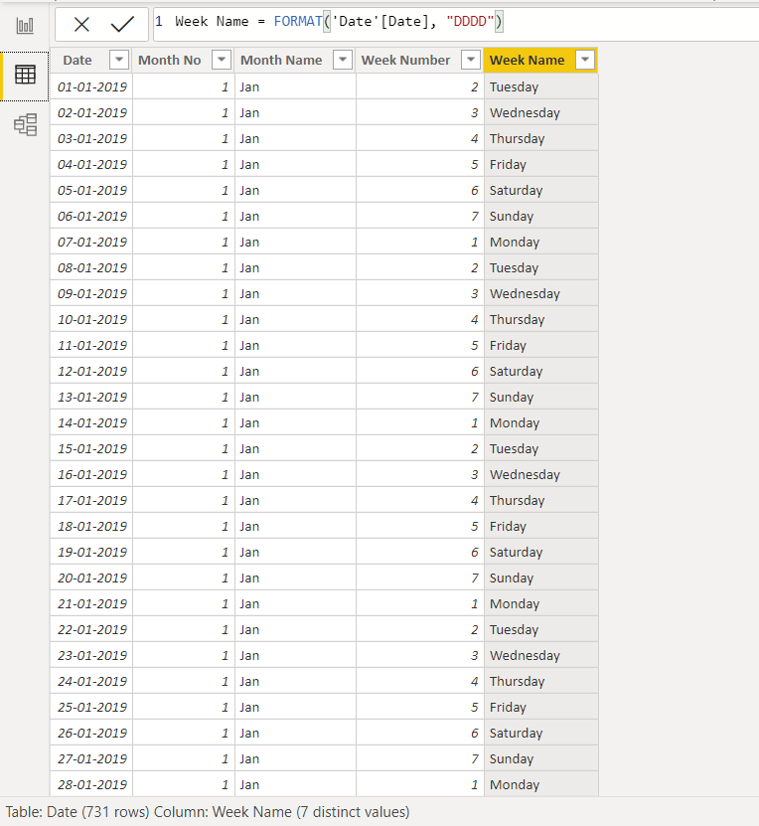

We need to sort Month Name and Week Name because otherwise they get sorted automatically usually alphabetically and we do not want that.

For sorting Month Name:

* Select Month Name 🡪 Column Tools 🡪 Sort By Column 🡪 Month No

For sorting Week Name:

* Select Week Name 🡪 Column Tools 🡪 Sort By Column 🡪 Week No

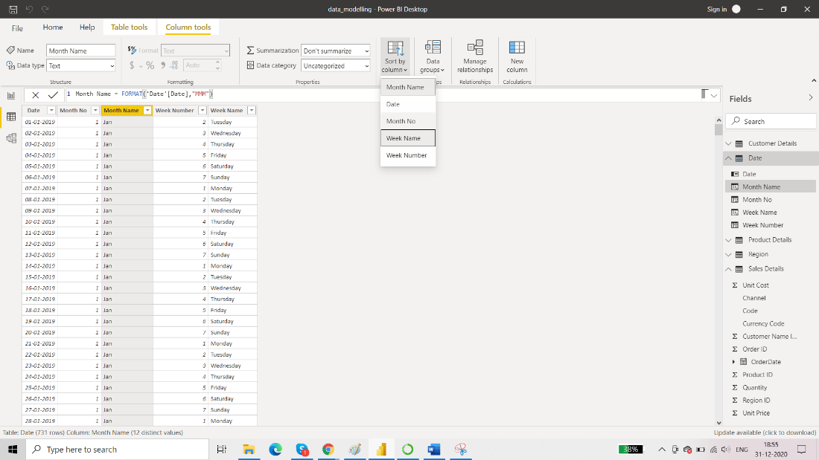

Final result:

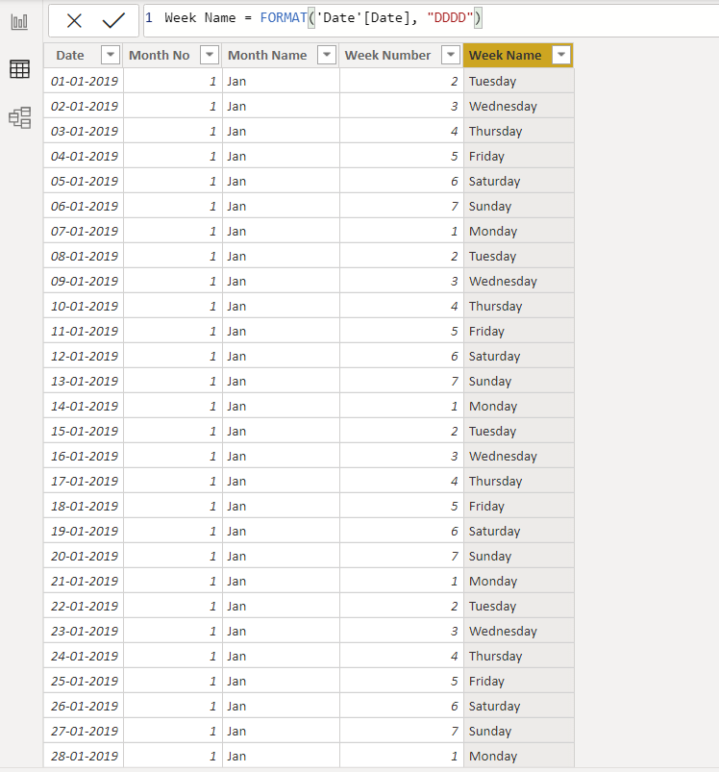

We can now remove Month No and Week No as we needed them just for sorting.

**Establishing connections between Fact table and Dimension Table**

Automatic connections:

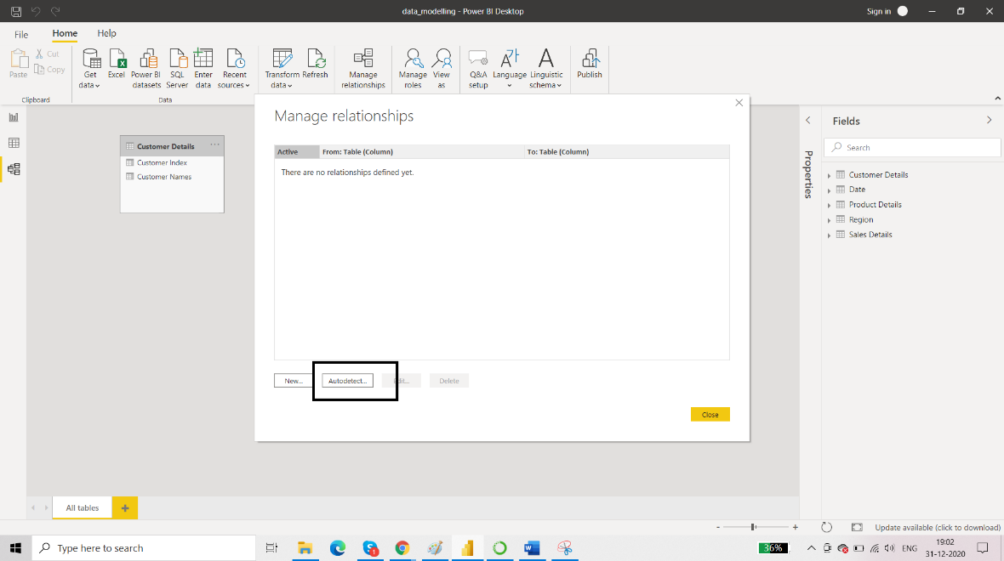

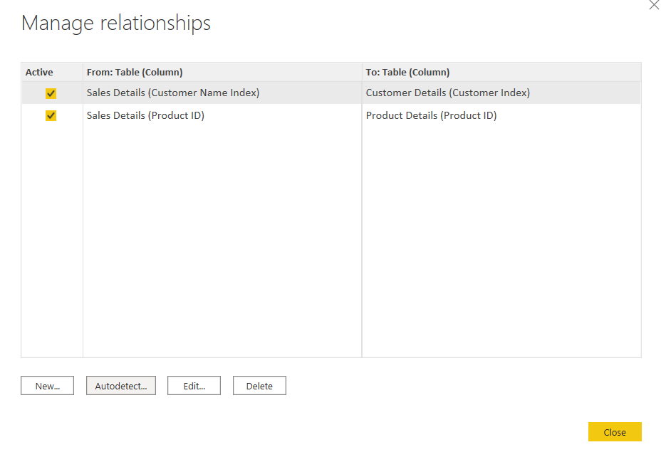

Only two connections are shown. One should have connections throughout the tables.

Manual Connection:

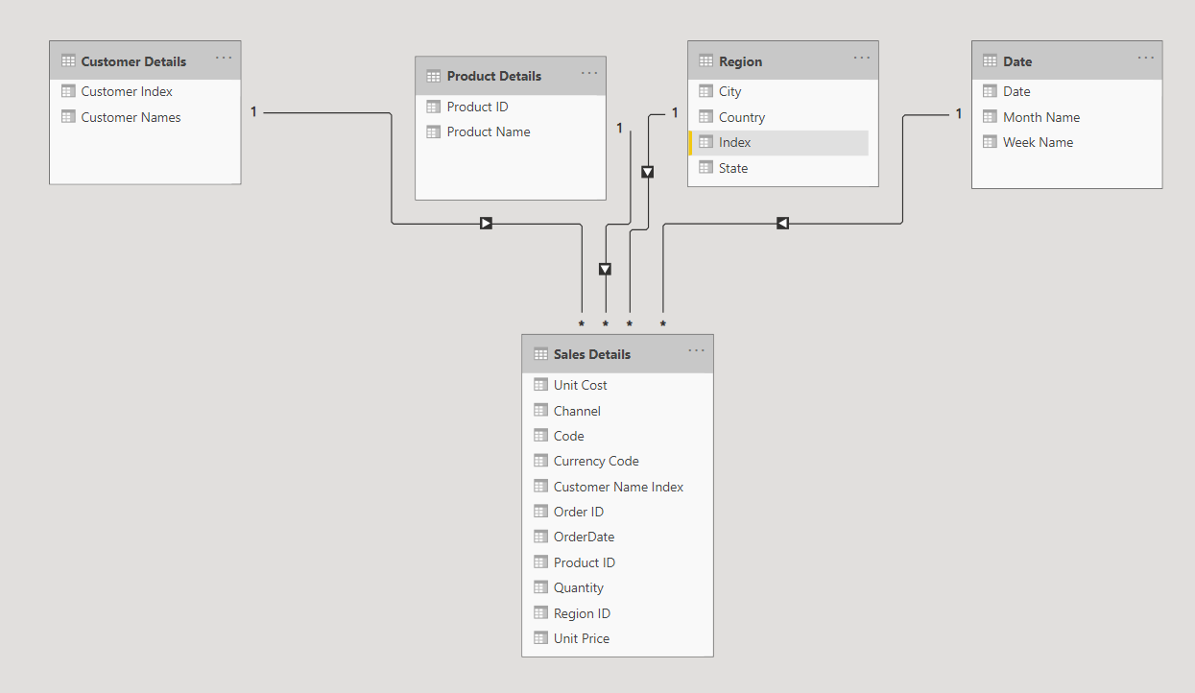

Arrows: cross filter directions. Here its value is ‘Single’. Meaning that we can apply filter on Fact Table (Sales Details) on the basis of Dimension Table (Region) and vice versa is not possible.

There are 4 types of connections. Each table must be connected to some other table via some connection meaning that there is at least one column that has same datatype in both the tables.

If you have multiple connections to a table then at a time only one connection is active.

REUIREMENT 6: Calculate Total Sales (with the help of DAX formula)

To achieve this, we can either create a column or create a measure. But we do not prefer creating a column because we don’t want to make data set heavier by adding more data in form of a column. Plus it will make the performance slow.

Creating a measure to calculate Total Sales:

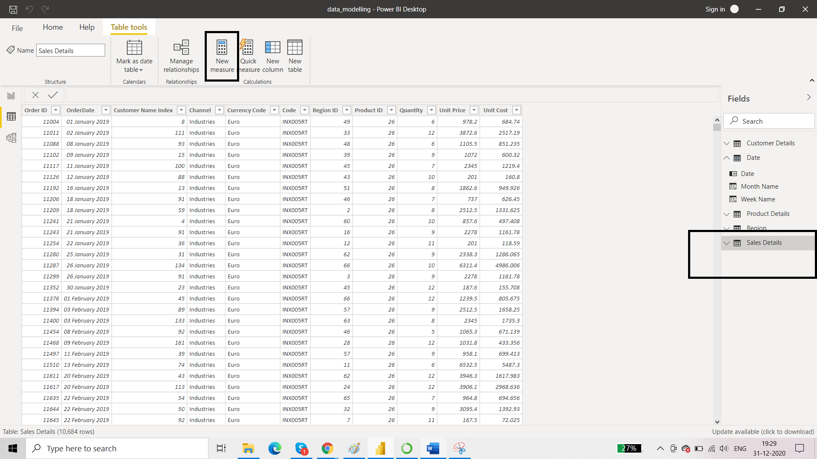

*Difference between Sum and Sumx

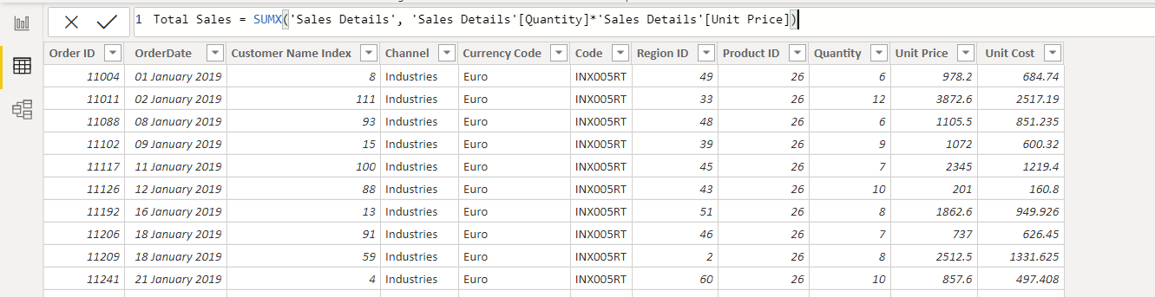

It will not result in the creation of any column.

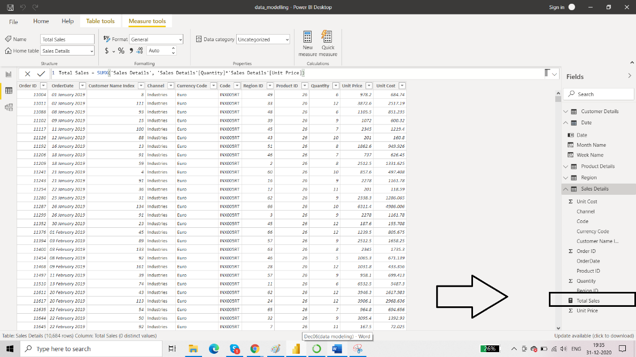

You can test it in the report view.

